Running Head: Mapping Media Perceptions

Mapping Media Perceptions:
Unveiling the Attitude Networks Towards News Media

Jayeon Lee
Dongyoung Sohn

Department of Media & Communication
Hanyang University, Seoul, Korea

Jayeon Lee is an Associate Professor and Dongyoung Sohn (corresponding author) is a Professor, both in the Department of Media & Communication at Hanyang University, 222 Wangsimni-ro, Seongdong-gu, Seoul, Korea. Phone: +82-2-2220-0855. Fax: +82-2-2281-4554. Email: dysohn@hanyang.ac.kr
Acknowledgement: This work was supported by the National Research Foundation of Korea (NRF) grant funded by the Korea government(*MSIT) (No.2018R1A5A7059549). *Ministry of Science and ICT

Mapping Media Perceptions: Unveiling the Attitude Networks Towards News Media

Abstract

This article presents a novel approach to understanding audience attitudes towards news media by applying network analysis: attitudes as networks. We explore the intricate connections among various cognitive and affective evaluative reactions and interactions between these reactions in the context of South Korean media outlets. By examining the attitude networks of general news media as well as specific media organizations based on our survey data (N = 500), and conducting pair-wise comparisons, we uncover unique patterns and crucial links that shed light on the complexity of audience reactions. The findings reveal that media outlets with distinct political stances and ownership structures exhibit.
Mapping Media Perceptions: Unveiling the Attitude Networks Towards News Media

The media landscape is undergoing rapid transformation. Constantly evolving technologies have revolutionized the creation, dissemination, and consumption of news over recent decades. Unlike the days of old media, now we have a wide range of media channels and mobile platforms catering to the diverse needs and preferences of audiences. These changes have had a profound impact on professional journalism and the broader media ecosystem (Katsaounidou et al., 2019). The proliferation of social media platforms and blogs has not only amplified the volume of news but also empowered audiences to curate and share news. Today, laypeople can report events in real time via mobile devices or even edit and repurpose existing news content to send out to a wide audience through social media networks.
Despite the ubiquity of news, concerns persist within the academic circles of journalism about a decline in overall news quality. These concerns are further exacerbated by emerging issues such as the swift dissemination of fabricated or manipulated information, often referred to as “fake news,” the formation of insular filter bubbles that limit exposure to diverse viewpoints, and subsequent political polarization (Lorenz-Spreen et al., 2023).
In light of the growing complexities in the media landscape, the importance of trust in journalism has reached unprecedented levels. Ever since Hovland and colleagues’ (1959) Yale Research Program that focused on credibility and attitude changes, audience trust has consistently been recognized as a critical variable in media studies (Tsfati, 2003). It serves as a foundational element in shaping how people perceive and evaluate news (Kohring & Matthes, 2007). As audiences are increasingly fragmented and traditional journalistic organizations face declining readership in the digital era, scholars underscore the role of trust as a pivotal factor that can either fortify or erode the influence of journalistic practice. For instance, Pew Research Center, a nonpartisan American institution that provides information about various social and political issues, regularly conduct national surveys on the public’s trust in news media as a proxy for public attitude toward news media. Its website has a category called “media attitudes” and “trust in media” is its only subcategory.
Gallup reports that Americans’ trust in the mass media has dropped from 72 percent in 1974 to 32 percent in 2016, and remains at a low point of 34 percent in 2022 (Brenan, 2022). The public trust level is even lower in South Korea. According to Reuters Institute’s Digital News Report 2023, just 28 percent of South Korean respondents said that they trusted most news most of the time (Lee, 2023). The public’s lack of trust in journalism is considered the biggest threat facing journalism today (Fink, 2019). Although journalism faces numerous challenges, it is said that public distrust in the media “brings together the concerns in one” (Lewis, 2020, p.44).
Despite the significance, however, the construct of trust, or credibility, in news media has been criticized for its lack of theoretical and methodological clarification (Earle & Cvetkovich; Kohring & Matthes, 2007). There is no standardized, validated measurement of trust (Kohring & Matthes, 2007; Metzger et al., 2003). Trust on individual media outlets is often assessed with a single item, by using credibility scales or simply asking how much trust they have in certain news media (e.g., Gottfried, 2021; Liedke & Gottfried, 2022; Roper, 1985). Pew Research Center asks, for instance, how much, if at all, respondents trust the information they get from national or local news organizations (Liedke & Gottfried, 2022). The meaning of trust is left to the interpretation of respondents and it is unclear what exactly is measured with the item (Kohring & Matthes, 2007). Also, empirical studies have found that people tend to evaluate vague, collective referents such as “the press” or “the media” more negatively than specific ones (Tourangeau et al., 2000). In other words, people may think of distrusted sources other people use when asked to answer generic media trust questions, while they have a higher trust level for the news sources they actually rely on (Daniller et al., 2017).
Some scholars use the term trust in surveys, while others adopt the term confidence aiming to assess the level of trust in news outlets. The General Social Survey (GSS) typically asks, for example, how much confidence respondents have in the press. The meaning of confidence in this context remains unclear. Some people may interpret it as inquiring about their confidence in the press’s ability to provide comprehensive and timely reports, while others may perceive it as a question about their beliefs in the journalistic ethics of the press (Daniller et al., 2017). American National Election Studies (ANES) and Gallup combine the two terms in one question and asks how much trust and confidence respondents have in the news media when it comes to reporting the news fully, accurately, and fairly (ANES 2020 time series study, 2021, Brenan, 2022). However, beliefs in accurate and fair reporting may not fully capture audience attitudes toward news media. In addition, accurate reporting does not always align with fair reporting. Someone might perceive a newspaper’s article as accurate but simultaneously feel that it is not necessarily fair for the paper to emphasize a particular aspect. These imprecise conceptualizations and measurements can create errors in study results.
It is crucial to understand audience attitude in the field of journalism. Particularly when it comes to discerning truth from fake news, audiences’ preexisting beliefs and attitudes can significantly affect their judgments (Moravec et al., 2018). However, despite its importance, the domain of journalism studies has largely relied on conventional approaches to conceptualizing and measuring attitude. Typically, survey respondents are asked to indicate their level of trust or confidence using a 5- or 7-point Likert scale, and these numerical responses are averaged to serve as proxy indicators of audience attitudes toward the media.
These conventional “averaging” methods indeed have limitations as they capture only one dimension of what is likely a multi-faceted concept of attitude, thereby overlooking its structural characteristics (Arnett, Davidson, & Lewis, 1936; Asch, 1948; Kohring & Matthes, 2007). In some instances, studies have attempted measure audience attitudes toward journalism via multiple inquiries, with the intention of exploring various dimensions of the news media, such as accuracy and fairness. Nonetheless, this more nuanced approach is not without its constraints, as it too resorts to averaging numerical responses to individual questions. Consequently, it hampers the examination of distinct dimensions of attitude and their interconnected interplay. For instance, the perceived accuracy level of a news media outlet might be influenced by its perceived fairness, with both factors collectively shaping overall attitudes toward the media.
However, the current method of numerically averaging responses into one number cannot reveal the intricate relations among these multifaceted attitude dimensions. Hence, it becomes imperative to explore the network structure that underpins these various facets of attitude. Specifically, within the field of journalism research, there is a notable lack of rigorous methodological investigations concerning the measurement of audience attitudes toward news media. This gap may partially stem from the perception that journalism is not primarily a commercial or strategic communication area, and its primary objective should not be understanding and changing audiences’ minds. Given that the declining trust of the audience drives changes of structural conditions of journalism (Lewis, 2020), however, it is vital to gain a deeper understanding of the perceptions and emotions that audiences hold toward news media. This understanding can inform efforts to rebuild and strengthen trust in journalism.
Measuring Attitude: A Network Approach
The measurement of trust is intimately tied to the measurement of attitudes, akin to how we tend to trust individuals we have a favorable disposition towards. The trust in news media often stems from various factors including their perceived fairness, accuracy, or independence, all of which contribute to shaping individuals’ attitudes. Consequently, evaluating individuals’ attitudes towards news media can serve as a crucial basis for discerning their level of trust in it. While the task of measuring trust in journalism has not been given enough attention, the realm of attitude measurement has been rigorously explored, especially within the contexts of advertising and persuasive communication (Haugtvedt & Kasmer, 2008; Eagly & Chaiken, 1993).
Attitude, a complex construct, has been traditionally conceptualized through a multi-faceted lens, often encompassing tripartite dimensions such as cognitive, affective, and behavioral facets (Fabrigar et al., 2005; Fazio, 2007; Eagly & Chaiken, 1993). Drawing from this multidimensional framework, scholars have ventured to measure attitude by using a series of correlated questions aimed at unveiling the underlying dimensions, a method known as the latent variable approach. The popularity of this approach can be largely attributed to its statistical harmony with empirical data. However, the assumptions anchoring this approach may border on the unrealistic, failing to capture the authentic mechanics of attitude (Dalege et al., 2016).
One of the core assumptions of the latent variable approach is the presumed independence of the underlying dimensions of attitude from each other. The analogy of measuring the temperature of an invisible object using three thermometers can serve as a representation of this assumption (Dalege et al., 2016). The consistency among the thermometers, undisturbed by each other, hints at the presence of a latent object. This parallels the independent yet revealing nature of the tripartite dimensions towards the latent construct of attitude. However, when applied to the realm of attitude measurement, this assumption inadvertently suggests that the cognitive evaluations of an attitude object remain unaffected by emotions or behaviors and vice versa, a notion detached from the intertwined reality of these dimensions.
For example, suppose a situation where you like a product’s design, but are not satisfied with its price. According to the latent variable approach, the liking for the design (affective dimension) should operate independently of the discontent with the price (cognitive dimension), and neither should impact your behavioral inclination towards making a purchase. This compartmentalization contradicts the well-established psychological principles of consistency and dissonance, a tendency to seek a harmonious alignment among cognitions, emotions, and behaviors, often leading individuals to modify their attitudes or perceptions to resolve any dissonance (Dalege et al., 2016).
The discrepancy between the assumptions of the latent variable approach and the interactions among the cognitive, affect, and behavioral dimensions calls for a more holistic approach that can encapsulate the intricate interplay among these dimensions while measuring attitude. The proposition to view attitude as a psychological network, wherein its elements are interdependent, marks a significant departure from traditional compartmentalization models. In the network-centric approach, a positive correlation between a pair of elements suggests a synergistic relationship in which activating one likely triggers the other, while a negative correlation implies that activating one could suppress or deactivate the other (Monroe & Read, 2008).
This posits that attitude functions as a psychologically activated network within one’s mind, where elements either harmonize or conflict with others. When elements within a network harmonize, activating and sustaining the network becomes more effortless while a network with conflicting elements demands more psychological energy. This concept echoes the often overlooked fact in social sciences that thinking is an energy-centric process. This, namely free energy principle, partially elucidates why human brains process information in a manner that minimizes the probability of surprise (Friston et al., 2006). This energy conservation tendency can be formally depicted using the Hamiltonian function, wherein the total energy fluctuates based on the harmony or discord among the elements. Consequently, the probability of a particular network’s occurrence can be expressed as a function of the total energy – as the required energy decreases (increases), the likelihood of the network’s presence increases (decreases).
Building on the aforementioned concepts, van Borkulo and her colleagues (2014) devised a method to estimate a network from binary data, melding Ising models from physics with logistic regression modeling. This novel approach facilitates the extraction of a network from a series of binary question items in a survey, thereby enabling an exploration of the interdependent relationships among attitudinal elements captured in the data. The nodes encapsulate various evaluative reactions ̶ such as beliefs, feelings, and behaviors ̶ related to the attitude object. This repositions attitudes as complex psychometric systems, the structure of which is open to empirical analysis (Dalege et al., 2016; Dalege et al., 2018).
In the current study, we employ this method to extract and estimate the attitude network concerning news media. We pose the following research questions to explore the different dimensions of audience attitudes in the context of South Korean news media:

RQ1. What structural variances manifest in attitude networks across different news media?
RQ2. Which elements emerge as significant players within the attitude network, and what factors underlie their influential role?

Portraying attitudes towards news media as a psychological network unveils a pathway to not only scrutinize how attitude networks differ based on the characteristics of news media but also help identify prominent elements exerting influence within each network.

Method
As a research context, we chose South Korea, where the public’s low trust in the news is regarded as a major characteristic of its media ecosystem (Lee, 2023). Data for this study were collected between August 24 and 29, 2023, through the services of Hankook Research, a research firm in South Korea. A total of 500 individuals from its online panel voluntarily participated in the survey for a small monetary reward after reading the online consent form. A hundred people were recruited for each age group, from those in their 20s to those in their 60s or older (M = 44.55, SD = 14.10), with half (50%) being male for each age group.
First, participants were requested to mark their positions on a 7-point scale between strongly disagree (1) to strongly agree (7) regarding a set of 21 statements about South Korean news media and South Korean news reports in general. The statements were designed to measure their perceptions (e.g., “South Korean news media pursue public interests” “South Korean news reports are accurate” “South Korean news reports are sensational” “South Korean news reports represent diverse opinions”) and mood or emotions about news they receive from the media (e.g., “South Korean news reports are interesting” “South Korean news reports make me angry” “South Korean news reports are boring” “South Korean news reports make me uncomfortable”).
Next, with the same set of 21 statements, participants were asked about individual news outlets instead of news media in general, starting from major national newspapers that represent the conservative voice (The Chosun Ilbo) and the liberal voice (Hankyoreh), followed by public broadcasting network owned by the government (KBS) and another network that has mixed characteristics of both public and commercial broadcasting (MBC), and two pay television networks (TV Chosun and JTBC). Finally, the same questions were asked about online content platform Naver and the global video sharing platform YouTube. Although Naver and YouTube are not news organizations, they were included in the list because they play significant roles in disseminating news and many South Koreans recognize the platforms as news media. Naver, that is equivalent to Google in South Korea, is the outlet that three out of four (74.2 percent) South Koreans receive news at least once a week (Lee, 2023). It even ranked as the second most credible news media, following KBS, in a survey conducted by Korea Press Foundation (2022). YouTube was selected by 96.8 percent as their news source in the same report.
After the set of attitude questions regarding various media outlets, participants were asked to indicate their use of traditional news media (M = 4.92, SD = 1.16) and online news (M = 5.30, SD = 1.13) on a 7-point scale from 1 (Almost never) to 7 (Almost always). Their use of social media was asked on the same scale. (M = 4.88, SD = 1.68). Political interest was measured by asking “What is your usual level of interest in politics?” on a 7-point scale from 1 (Very low) to 7 (Very high). (M = 4.65, SD = 1.37). Political identity was measured by asking participants to indicate their political leaning on a 7-point scale from 1 (Very liberal) to 7 (Very conservative) (M = 3.86, SD = 1.19). These measures aimed at capturing the respondents’ media use behaviors alongside political engagement and stances, serving as potential covariates for further analysis within the study.
Finally, questions for demographic information were included. Education was measured with seven choices (1: graduated from middle school or lower, 2: graduated from high school, 3: vocational school or two-year college degree, 4: four-year college degree, 5: some grad school, 6: Master’s degree, 7: Doctoral degree.) The average participant’s highest education level fell between vocational school/two-year college degree and four-year college degree (M = 3.45, SD = 1.10). The average household income range was between 4,000,000 – 5,000,000 Korean won (3,000 – 3,700 US dollar) on a 1 (1,000,000 won or lower) to 9 (9,000,000 won or higher) scale (M = 5.35, SD = 2.53).

Results
Following the procedure delineated by Dalege and his colleagues (2016), attitude networks were estimated pertaining to a total of nine different media outlets, with covariates such as respondents’ gender, age, and political identity held constant. Through the eLasso procedure proposed by van Borkulo and her colleagues (2014), each variable was regressed on all other variables in turn, and the best fitting regression function was selected based on the extended Bayesian information criterion (BIC). One of these networks pertains to the general news media in South Korea, serving as a baseline model for comparison with networks for each specific news media. The remaining eight networks encompass selected news media, including national newspapers, broadcasting stations, and online media.

 | Network Density (%) | Clustering (%) | Distance | Entropy
The Chosun Ilbo | 33.81 | 49.66 | 4.64 | 4.09
Hankyoreh | 36.67 | 51.15 | 6.08 | 4.21
KBS | 33.33 | 49.17 | 5.49 | 4.09
MBC | 33.81 | 43.98 | 4.31 | 4.07
TV Chosun | 33.81 | 43.94 | 4.64 | 4.13
JTBC | 32.38 | 49.04 | 5.28 | 4.04
Naver | 32.86 | 42.45 | 5.83 | 4.04
YouTube | 34.29 | 43.60 | 5.41 | 4.06
General News Media  (baseline) | 37.14 | 46.40 | 5.14 | 4.15

Table 1. Descriptive Statistics of Attitude Networks

Table 1 presents the descriptive statistics of the nine causal attitude networks. The first column, network density, represents the proportion of existing connections in each network, indicating that, for instance, approximately 37% of all possible pairs among the 21 nodes had statistically meaningful relationships in the attitude network for general news media. Activation of nodes is facilitated in A densely connected network.
The second column, clustering, represents the extent to which closed triangles (where three nodes are connected with one another) exist in the network, indicating the potential spreading of activity through the network. Hankyoreh, a progressive newspaper, was found to exhibit the highest degree of clustering, while Naver had the lowest. The higher degree of clustering suggests the presence of a denser interconnectedness among the evaluative factors in some parts of the network, implying that perceptions or evaluations regarding one aspect are likely to influence those regarding others.
Distance, shown in the third column, indicates how closely the nodes in a network are connected, often represented by the shortest average distance among all nodes in a network. A shorter average distance implies that the nodes are more coherently connected, enabling any node to reach another with a shorter travel distance. In this context, an attitude network with a shorter distance score means that the nodes are closer to one another, indicating higher attitude strength. Our data shows that MBC, a public broadcasting station, had the shortest average path length, indicating the highest attitude strength, followed by Chosun Ilbo and TV Chosun, while Hankyoreh had the longest average path length, indicating the lowest attitude strength.
Lastly, entropy measures the structural complexity of a network. Higher entropy indicates a more dispersed distribution of edges in a network, while lower entropy suggests a more centralized or concentrated distribution of edges. Given a network with 21 nodes, the maximum possible entropy is 5.347, and all the attitude networks were around 4.1, indicating they possess moderately dispersed structures.

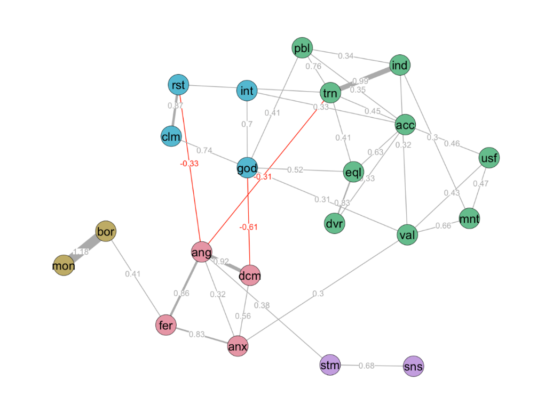
Figure 1. Attitude Network of the General News Media in South Korea
Note: Covariates, such as gender, age, political ideology, are controlled, but not displayed. Node labels and their full forms are as follows -- val - News Value, mnt - Social Monitoring, ind - Independence, trn – Transparency, pbl - Public Interest, acc - Accuracy, usf - Useful, sns - Sensational, eql - Equality, dvr - Diversity, god - Feeling Good, int - Interesting, stm - Stimulating, dcm - Discomfort, anx - Anxious, ang - Angry, fer - Fear, clm - Calm, rst - Restful, bor - Boring, mon - Monotonic

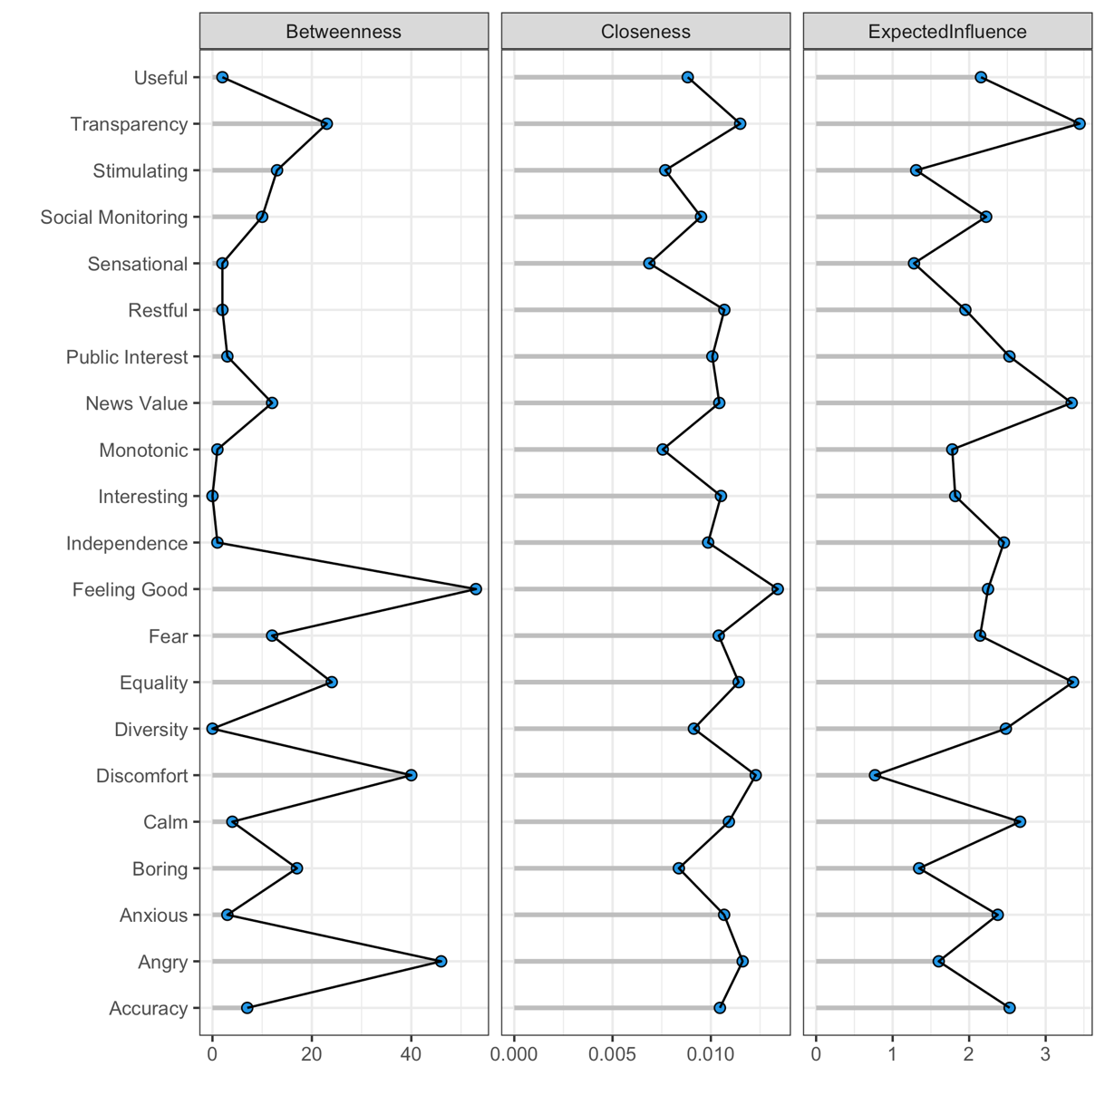
Figure 2. Centrality Analysis of Attitude Network of the General News Media in South Korea
Note: Expected influence is a measure of the degree centrality of a weighted network

Figure 1 depicts the attitude network of general news media, displaying only connections with a regression weight exceeding 0.3. The network comprises five densely tied local areas, each represented by different colors. For instance, four nodes labeled ‘interesting’, ‘restful’, ‘calm’, ‘feeling good’ are colored blue, forming a dense local network, while other four nodes labeled ‘angry’, ‘discomfort’, ‘fear’, ‘anxiety’ are colored pink, forming another cluster. Typically, similar perceptions and emotions are more closely connected than dissimilar perceptions and emotions. Gray edges indicate excitatory influence, and red edges indicate inhibitory influence between the nodes. Thicker edges represent higher weights of the edges.
A point of interest in this graph is the negative association between ‘angry’ with ‘transparency.’ This implies that the issues of transparency, rather than other aspects like ‘accuracy’ or ‘diversity,’ directly incite feelings of anger toward news media, which in turn can prompt other negative emotions such as discomfort, fear, and anxiety. ‘Interesting’ and ‘equality’ were directly linked to ‘feeling good,’ a positive mood that can reduce ‘discomfort.’
The network approach offers a distinct advantage by enabling the examination of the relative importance or prominence of nodes within a network. Figure 2 presents the results of three different centrality analyses: betweenness, closeness and expected influence. Betweenness centrality measures the extent to which a node is situated between pairs of other nodes within the same network. A node with higher betweenness centrality signifies that it occupies a bridging or brokerage position. It signifies how important a node is in the flow of information. Whether a change that takes place in cluster spreads to other clusters depends on the high betweenness nodes that connect the clusters.
Closeness centrality quantifies the average shortest path length from a node to all other nodes within the same network. On the other hand, expected influence, while related to degree centrality in the context of weighted networks, typically incorporates not just the number of connections a node has, but also takes into account the strength or weights of those connections. If change occurs in a node of high closeness and high expected influence, it will bring more impact than when it happens in a node of low closeness and low expected influence.
The results of the analyses revealed that, while all nodes in the attitude network for general news media did not exhibit significant differences in terms of closeness or expected influence, they were quite varied in terms of betweenness centrality. Notably, ‘feeling good’ and ‘angry’ were found to have the highest betweenness centrality scores. This suggests that these basic emotions occupy pivotal positions that can determine the extent to which changes in a node can propagate throughout the entire network. In other words, they act as gatekeepers of emotional processing – people’s cognitive evaluations of various elements of news media are initially linked to the degree to which they feel anger, which subsequently influences other emotions like discomfort. Considering the pivotal role of high-betweeness nodes, inducing feelings of happiness or anger is consequential as it can activate numerous cognitive and emotional evaluations within the attitude network.
Next, attitude networks for two specific news media, the conservative Chosun Ilbo and the progressive Hankyoreh, were extracted and visually analyzed, as depicted in Figure 3. Contrary to the attitude network for general news media, the attitude networks for these specific media outlets were found to comprise two local areas, suggesting that the network is less partitioned and leans towards a single, integrated component. As indicated in Table 1, the Chosun Ilbo exhibited higher connectivity than Hankyoreh, with the latter having the lowest closeness. This suggests that people tend to hold stronger attitudes toward the Chosun Ilbo than toward Hankyoreh. This difference in network structure is also evident Figure 3. In the attitude network of Chosun Ilbo, two local networks, represented by green and pink areas, are interconnected through nodes such as ‘useful’ and ‘public interest.’ In contrast, the network for Hankyoreh consists of two separate components with no connections between them.
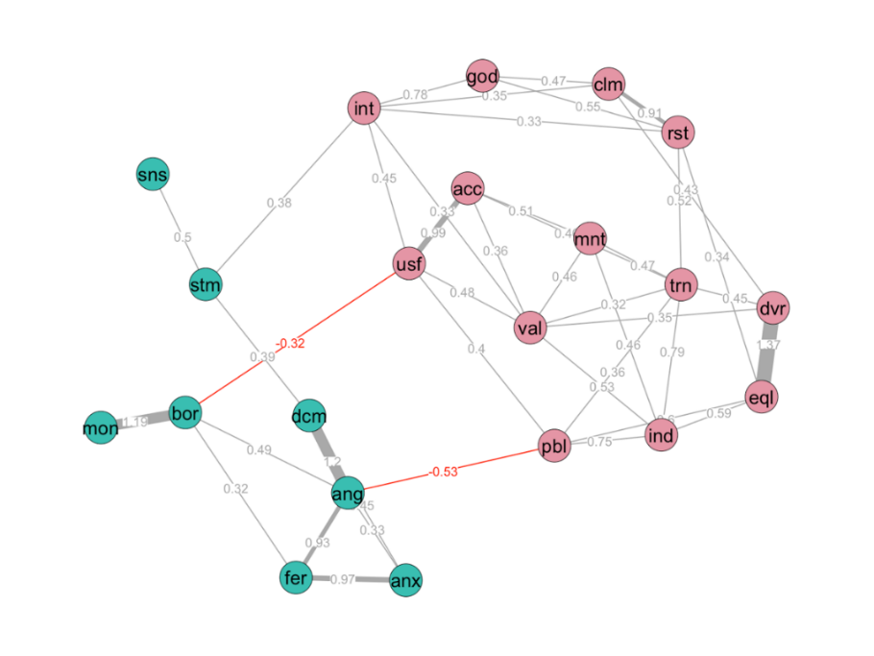
- Conservative (The Chosun Ilbo)
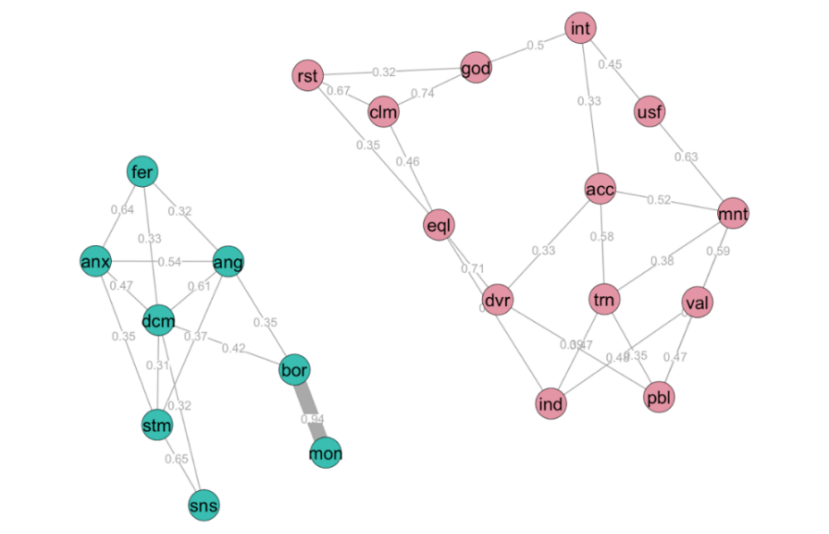
- Progressive (Hankyoreh)

Figure 3. Attitude Networks of Newspapers (Conservative vs. Progressive)
Note: Covariates, such as gender, age, political ideology, are controlled, but not displayed

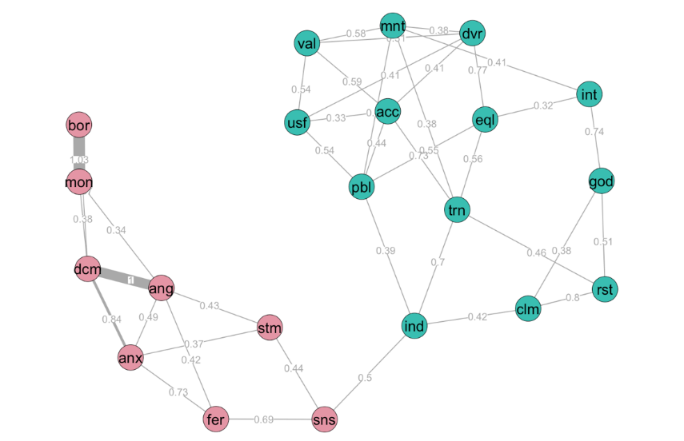
- Public (KBS)
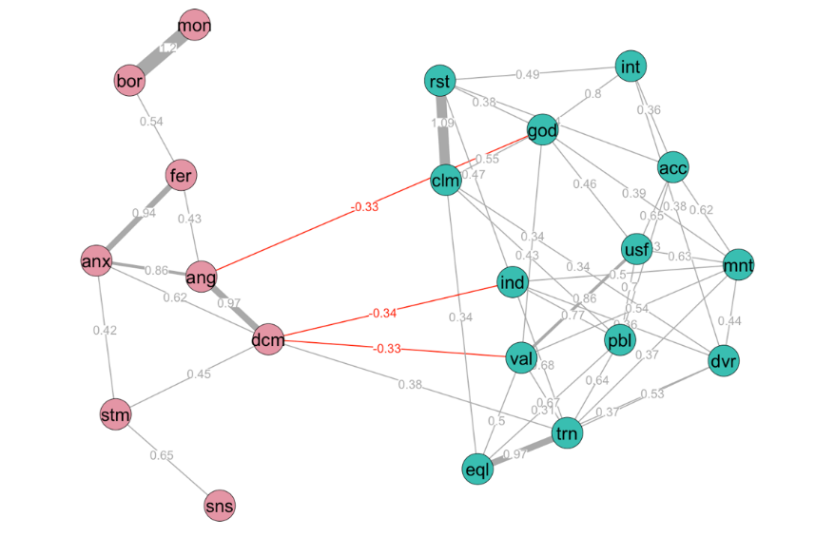
- Private (TV Chosun)
Figure 4. Attitude Networks of Broadcast News (Public vs. Private)
Note: Covariates, such as gender, age, political ideology, are controlled, but not displayed
Interestingly, in the case of the Chosun Ilbo, the issue that elicited anger towards the media was identified as ‘public interest.’ Considering that ‘transparency’ prompted anger in the baseline network, this result suggests that the specific issues provoking anger may vary across different media outlets. Chosun Ilbo, arguably acknowledged as the most influential newspaper in South Korea (Kim, 2018), may evoke negative responses from people when it appears to prioritize private interests over public ones.
Conversely, Hankyoreh appears to lack connections between its two partitioned areas, indicating that individual may find it challenging to link their emotions to their cognitive evaluations. While ‘equality’ was connected to ‘calming’ and ‘restful’, it remained unclear what could potentially trigger anger or discomfort among Hankyoreh readers, given its separated structure. It appears that whatever perception they hold regarding this newspaper, it does not strongly evoke their emotions.
Figure 4 presents another example of a pairwise comparison, showcasing the attitude networks for two broadcasting stations: KBS, a public station, and TV Chosun, a private station. The attitude network for KBS was discovered to encompass two local areas that were largely disconnected, suggesting that, akin to Hankyoreh, individuals might have difficulties in linking emotional responses to their cognitive appraisals.
Conversely, the attitude network for TV Chosun, a commercial cable television station, shows a distinct pattern, with the two local partitions exhibiting a negative association. Paricularly, ‘independence’ and ‘news value’ were found to be negatively correlated with ‘discomfort.’ This implies that viewers tend to feel discomfort when commercial televisions like TV Chosun appear to lack independence or broadcast content with low news value. These feelings of unease can lead to anger and subsequently trigger anxiety and fear through the pathway of anger.
In addition to the visual and descriptive inspection of each attitude network, we employed the network permutation method to conduct pairwise statistical comparisons between each of the four media outlets examined above and the general news media, which served as the baseline. Among the four media outlets, the Chosun Ilbo, $g= 13.31, p < .001$, and TV Chosun, $g = 12.55, p < .001$, were found to have attitude networks that significantly deviated from the general news media in terms of global network strength. As indicated in Table 1, these two attitude networks exhibited a significantly shorter average shortest path length than the baseline, indicating more coherent attitude networks.
While no significant difference was found among all media outlets from the baseline in terms of global network structure (i.e. link weight distribution), some specific edge weights were identified as significantly different. Figure 5 illustrates four cases of link-by-link comparisons between two selected attitude networks, displaying only links with statistically significant differences. Links are represented in red if the tie intensity in the former network is smaller than the latter (i.e., baseline) and in green otherwise. In the context of negative relationship, the red link indicates that the intensity in the former network is greater than the latter.
Notably, regarding Chosun Ilbo, ‘equality’ displayed significantly stronger link weights toward ‘independence’, $d =-0.46, p < .01$, ‘diversity’, $d =-0.46, p < .01$, and ‘restful’, $d =-0.46, p < .01$, compared to general news media $(Figure 5a)$. This suggests that enhancing the perception that the newspaper’s news reports are balanced may be an effective strategy to increase the perception of independence, diversity and feelings of relaxation. In addition, by bolstering its image as a source of useful information, the paper can enhance perceptions of ‘accuracy,’ ‘public interest,’ and ‘interest,’ while simultaneously reducing the perception of being boring, $d =-0.46, p < .01$ (Figure 5b).
For Hankyoreh, emphasizing ‘equality’ might not be the most effective strategy, as its links to ‘feeling good’ and ‘social monitoring’ were found to be weaker compared to the baseline model, $d =-0.93, p < .01$, $d =-0.93, p < .01$. People may perceive Hankyoreh as a progressive citizen-owned paper that emphasizes transparency and equality, but this doesn’t necessarily make them feel more positively about its news reports. However, emphasizing ‘equality’ holds value, as it is strongly linked to ‘independence’ and ‘restful’ feelings (Figure 5b).
When it comes to KBS, the link between ‘public interest’ and ‘transparency’ was significantly weaker than the baseline, $d =-1.49, p < .01$. This suggests that as a national, public broadcaster, KBS may convey a commitment to public interest, which strengthens the perception that it provides useful information, $d =0.98, p < .01$. However, this commitment doesn’t seem to align with the perception that the government-funded medium operates transparently (Figure 5c). Lastly, an interesting observation concerning TV Chosun is the weaker link between ‘diversity’ and ‘equality’ compared to the baseline. The association between the perception that the cable channel’s news reports are balanced and the perception that it represents diverse voices is less strong than in the baseline model (Figure 5d).

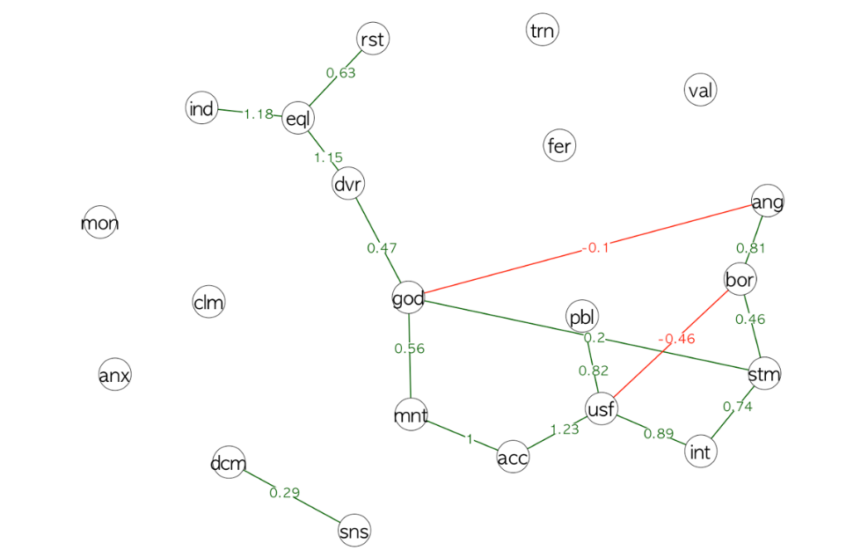
- Conservative (The Chosun Ilbo) $–$ General News Media (Baseline)
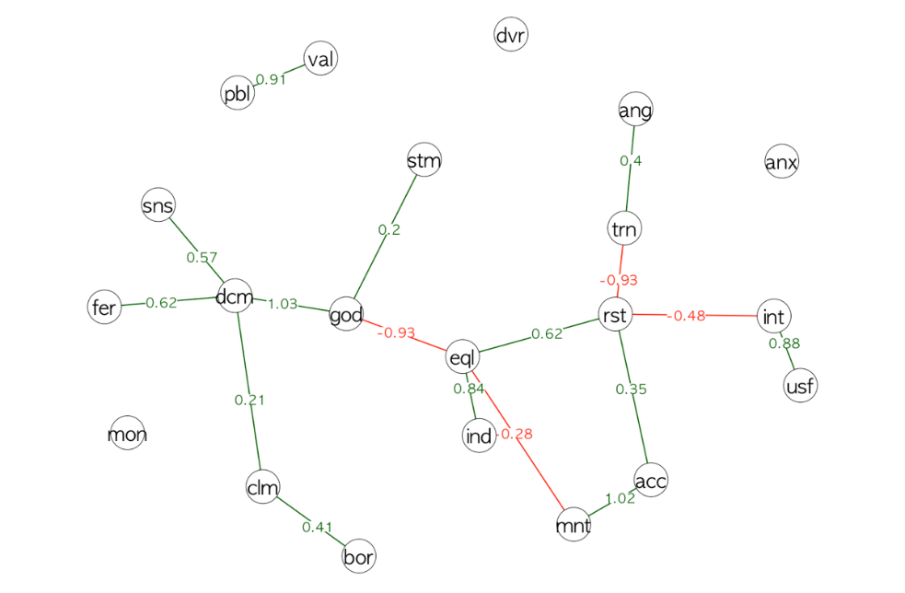
- Hankyoreh (Progressive) $–$ General News Media (Baseline)

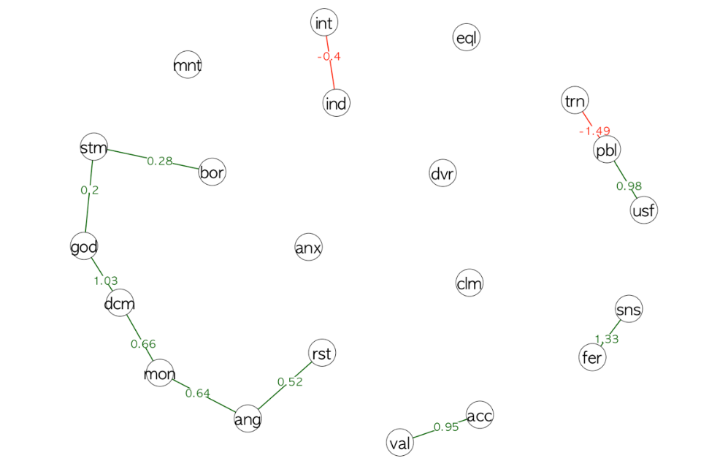
- KBS (Public Broadcasting Station) $–$ General News Media (Baseline)
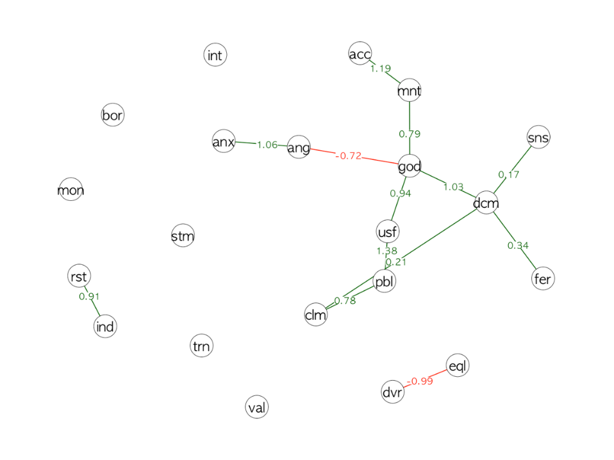
- TV Chosun (Private Broadcasting Station) $–$ General News Media (Baseline)

Figure 5. Statistical Comparison of Networks
Note: Only edges with $p ≤ .05$ are shown in the figure. Red lines indicate that the edge intensity of the former network is smaller than that of the latter, while green lines represent the opposite.

Discussion
When viewing the world as a vast network, complex truths hidden behind familiar phenomena come into view. In this hyper-connected era where individual minds extend to connect people and shape societies, portraying thoughts and feelings as a network may serve as a crucial starting point for a more nuanced understanding of the complex processes of communication. The age-old concept of attitude, which has been a cornerstone in persuasive communication, reveals numerous unexplored issues when examined through the lens of a network.
While most previous endeavors to measure people’s attitudes or trust levels toward news media have culminated in obtaining aggregated scores, such as high or low attitude scores, examining attitude networks exposes which cognitive elements are associated with positive or negative emotions. This insight illuminates which elements tend to make people feel uncomfortable and angry, providing a nuanced understanding beyond merely comparing aggregated scores across media. For instance, by constructing a network of the overall attitude that voters have towards a presidential candidate, it becomes possible to analyze the relationships among various evaluation factors of the candidate, such as honesty, fairness, sincerity, and leadership (Dalege et al., 2016). Through this analysis, one can identify which part represents a weak link, where mutual conflict occurs, and what perception strongly evokes negative emotions, thereby enabling the opportunity for detailed improvements.
The findings from the current study show that estimating attitude networks towards various news media not only enables an examination of the structural characteristics of people’s attitudes towards each news medium beyond merely obtaining an aggregated score, but also facilitates comparisons to highlight subtle differences in structure that may have been overlooked previously. While it’s commonly posited that sensational and stimulating news might evoke anger and discomfort among individuals, our results indicate that a lack of transparency regarding the production and distribution of news might be a fundamental reason underpinning their negative reactions to news media (Figure 1). This suggests that South Koreans predominantly hold a normative view that news media should operate in a transparent manner. Accuracy, on the other hand, had the highest number of direct connections to other nodes, implying that improving the accuracy of news can effectively improve audience perceptions in other dimensions such as equality, usefulness, transparency, and news value.
The analyses of specific news media unravel varying narratives. People tend to exhibit a stronger attitude network towards Chosun Ilbo, a prominent newspaper with a conservative stance, compared to its progressive counterpart, Hankyoreh. This disparity seems to be rooted in the connectivity between cognitive appraisals and emotional responses. In the case of the conservative newspaper, individuals were particularly incensed by the perceived prioritization of private interest over public ones. For Chosun Ilbo, which is owned and run by the family that established it, the perception of pursuing private interests can trigger anger, which subsequently leads to discomfort, fear, and anxiety (Figure 3a). On the flip side, individuals showed relatively weaker emotional responses towards the cognitive appraisals of Hankyoreh. This could be partly attributed to its citizen-owned model, which may result in a different level of emotional investment. It remains unclear what specific factors cause anger or discomfort among readers of this paper, given the segregation between cognitive and emotional dimensions of their attitude.
The divergence in emotional response was also observed when comparing two broadcasting television stations, one public and the other private. It was discovered that individuals had relatively weak connections between their cognitive appraisals and emotional responses regarding KBS, a public broadcasting station. The two clusters were connected only through ‘independence’ and ‘sensationalism’ – the more independent from external influences, the more sensational it may become. This might seem counterintuitive, but it underscores the complexity of the issue of independence. Upon reflection, people may perceive KBS’s news as being less sensational due to government oversight (i.e., less independent). Alternatively, they might view KBS as relatively free from external pressures, including the government’s control, given its sensational content. Although the overall network strength is low, given that ‘transparency,’ ‘accuracy,’ ‘public interest,’ and ‘social monitoring’ had the most connections (i.e., 5) to other nodes among cognitive appraisals, working on any one of these perceptions can have a ripple effect, influencing multiple other perceptions.
In contrast, stronger cognition-emotion connections were observed concerning TV Chosun, a privately-owned channel. The result reveals that perceptions of low independence and low news value regarding this channel can evoke discomfort. It indicates that individuals feel uneasy when they see the medium as lacking independence due to its private ownership or when they believe it offers news of lower value. These findings underscore the significance of perceived independence and news value in shaping audiences’ emotional reactions to TV Chosun. Because it was established as a subsidiary of Chosun Ilbo, people might possibly perceive it as inherently lacking in independence compared to public news media, which can undermine the perceived newsworthiness of the stories they deliver. These perceptions can, in turn, trigger discomfort in the minds of the audience, a sentiment closely related to anger.
Statistical pairwise comparisons of each attitude network with the baseline (i.e., general news media) (Figure 5) provide insights into the crucial links specific to a particular medium when compared to news media in general. In the case of Chosun Ilbo, ‘useful,’ which is a central perception directly linked to five other nodes in the attitude network (Figure 3), exhibited a notably stronger connection to ‘accurate’ than the baseline. This suggests a strategic approach for the paper: By enhancing the public’s perception of the accuracy of its news articles, the paper can effectively elevate perceptions of ‘usefulness,’ ‘social monitoring’ ‘transparency,’ and ‘news value’, and ‘useful’ itself triggering other positive perceptions.
It is notable that people have the lowest attitude strength regarding Hankyoreh, which also has the highest entropy – the most dispersed distribution of edges in a network. It seemed that ‘accurate’ directly led to ‘interesting’ in Hankyoreh’s attitude network, which in turn was connected to positive emotions through ‘feeling good’ in Figure 3b. However, the pairwise comparison with the baseline revealed that ‘accurate’ was linked to ‘interesting’ through ‘restful’, which was more strongly tied to ‘accurate.’ This suggests that it might be more challenging for the paper to effectively influence readers’ overall emotional appraisals by emphasizing a few cognitive perceptions due to its dispersed network. One possible strategy could involve emphasizing the usefulness of its news reports, as this can elevate the ‘interesting’ perception as the two perceptions are more strongly connected than the baseline.
When examining KBS, the relatively strong link between ‘anger’ and ‘monotonous’ stands out as an interesting focal point. This connection suggests the network television has the potential to provoke anger among audiences simply by delivering monotonous news reports. This connection, that is unique to KBS, implies the delicate balancing act that news media must navigate to cater to the diverse expectations and needs of their audiences by crafting a blend of informative yet engaging content. The notably weak relationship between ‘transparency’ and ‘public interest’ concerning KBS may indicate a dissonance among audiences. People may perceive KBS as serving the public interest as the public broadcaster, but they may not necessarily view its operation more transparent than other media.
In the attitude network of TV Chosun, cognitive evaluations were intricately connected to emotional appraisals, particularly through ‘discomfort.’ One strategic approach the company can consider is paying more emphasis on improving the audience’s perception of ‘independence,’ as it is connected negatively to ‘discomfort’ and positively to ‘restful’, ‘transparent’ and ‘social monitoring.’ The link between ‘independence’ and ‘restful’ is particularly strong, highlighting the importance of independence in ensuring audience comfort. These results also raise the possibility that, regardless of their ideological stance, South Koreans may generally be more inclined to have emotional reactions to privately-owned media compared to publicly owned ones. This finding reflects a broader apprehension towards privately-owned media outlets, where the owner’s interests might, in the eyes of the public, compromise the autonomy of the media.
It is important to note that the findings of the present study should be understood within the context of its limitations. Firstly, the questionnaire included a total of 21 cognitive perceptions and emotional evaluations about news media. While these statements were derived from previous studies and reports, they do not constitute an exhaustive list of components that contribute to attitudes toward news media. Adding another significant node could potentially alter the network structure.
In a similar vein, not all media outlets were included in the analyses. While we compared KBS and TV Chosun, they may not comprehensively represent other public broadcasting channels and cable television channels. People might have varying attitudes with different network characteristics toward different media organizations, however, we selected one representative from each category for the pairwise comparison with the baseline.
We should also acknowledge that survey participants may have answered the questionnaire without having sufficient experiences with individual news media outlets. Notably, only 9.7% of South Koreans read physical newspapers, while a significant majority (84.1%) read newspaper articles through social media, messaging services, or news aggregation sites (Korea Press Foundation, 2022). Consequently, it is possible that they do not always check or accurately remember the source of each article they encounter. This makes it challenging for individuals to form concrete attitudes toward individual news sources. Participants might have responded to the questions about nine different media outlets based on affective gut reactions and partial impressions they have in mind, which could potentially lead to higher error rates.
Nonetheless, the results of our analyses shed considerable light on the nature of attitude network toward news media people formed based on their experiences and impressions. As discussed above, the network approach allows to dissect the intricate web of cognitive and emotional connections people form with various media outlets, lending a more comprehensive understanding of the public’s media consumption behaviors and expectations. It underscores the dynamic interplay of diverse evaluative factors, providing a more granular comprehension of how different attributes of news media resonate with the audience. The significant links and disparities revealed in the attitude networks across different media outlets suggest that attitudes are not mere linear assessments but complex networks of interrelated evaluations. In an academic context, attitude networks allow researchers to delve into the multifaceted nature of how the public’s views on news media are constructed and evolve over time, offering a more detailed lens through which the dynamism of public sentiment can be studied. Practically, this approach serves as a diagnostic tool for media companies, enabling them to meticulously assess their current standing in the eyes of the public. This will empower media entities to craft informed communication strategies aimed at enhancing their strengths and addressing the weaker aspects of their public perception.
This study showcases an attempt to capture the network structure of attitude toward news media. As we lay a groundwork for the task, we encourage journalism scholars to further investigate the development and changes of audience attitudes through the means of network analysis over time.

References

Brenan, M. (2022). Americans’ trust in media remains near record low. Retrieved October, 26, 2023 from https://news.gallup.com/poll/403166/americans-trust-media-remains-near-record-low.aspx
Dalege, J., Borsboom, D., van Harreveld, F., van den Berg H., Conner, M., & van der Maas, H. (2016). Toward a formalized account of attitudes: The Causal Attitude Network (CAN) model. Psychological Review, 123, 2–22.
Dalege, J., Borsboom, D., van Harreveld, F., & van der Maas (2018). The Attitudinal Entropy (AE) framework as a general theory of individual attitudes. Psychological Inquiry, 29, 175–193.
Daniller, A., Allen, D., Tallevi, A., & Mutz, D. C. (2017). Measuring trust in the press in a changing media environment. Communication Methods and Measures, 11, 76–85.
Eagly, A. H., & Chaiken, S. (1993). The psychology of attitudes. Harcourt Brace Jovanovich College Publishers.
Earle, T. C., & Cvetkovich, G. T. (1995). Social trust. Toward a cosmopolitan society. Greenwood Publishing Group.
Fabrigar, L. R., MacDonald, T. K., & Wegener, D. T. (2005). The structure of attitudes. In D. Albarracín, B. T. Johnson, & M. P. Zanna (Eds.), The handbook of attitudes (pp. 79–125). Erlbaum.
Fazio, R. H. (2007). Attitudes as object-evaluation associations of varying strength. Social Cognition, 25, 603– 637.
Fink, K. (2019). The biggest challenge facing journalism: A lack of trust. Journalism, 20, 40–43. https://doi.org/10.1177/146488491880706
Friston, K., Kilner, J., & Harrison, L. (2006). A free energy principle for the brain. Journal of Physiology-Paris, 100, 70–87.
Gottfried. Pew Research Center. Republicans less likely to trust their main news source if they see it as ‘mainstream’; Democrats more likely. Retrieved October, 28, 2023, from https://www.pewresearch.org/short-reads/2021/07/01/republicans-less-likely-to-trust-their-main-news-source-if-they-see-it-as-mainstream-democrats-more-likely/
Haugtvedt, C., & Kasmer, J. A. (2008). Attitude change and persuasion. In C. P. Haugtvedt, P. M. Herr & F. R. Kardes (Eds.), Handbook of consumer psychology (pp. 419–435). Routledge.
Hovland, C. I., Janis, I. L., & Kelley, H. (1959). Communication and persuasion. Psychological Studies of Opinion Change (3rd ed.). Yale University Press.
Katsaounidou, A., Dimoulas, C., & Veglis, A. (2019). The transforming media landscape. In Cross-media authentication and verification: Emerging research and opportunities (pp. 39–61). Academic Press. https://doi.org/10.4018/978-1-5225-5592-6.
Kim, H. (2018). Korean journalism. In Yoon, K. (Ed.). Digital media and culture in Korea. Communication, digital media, and popular culture in Korea: Contemporary research and future prospects (pp. 283–300). Lexington Books.
Kohring, M., & Matthes, J. (2007). Trust in news media: Development and validation of a multidimensional scale. Communication Research, 34, 231–252.
Korea Press Foundation (2022). Media users in Korea. Retrieved in October 28, 2023 from https://www.kpf.or.kr/synap/skin/doc.html?fn=1675144529256.pdf&rs=/synap/result/research
Lee, H. (2023). South Korea. Digital News Report 2023. Reuters Institute. Retrieved from https://reutersinstitute.politics.ox.ac.uk/digital-news-report/2023/south-korea
Lewis, S. C. (2019). Lack of trust in the news media, institutional weakness, and relational journalism as a potential way forward. Journalism, 20(1), 345–348.
Liedke, J, & Gottfried, J. (2022). U.S. adults under 30 now trust information from social media almost as much as from national news outlets. Pew Research Center. Retrieved October 28, 2023, from https://www.pewresearch.org/short-reads/2022/10/27/u-s-adults-under-30-now-trust-information-from-social-media-almost-as-much-as-from-national-news-outlets/
Lorenz-Spreen, P., Oswald, L., Lewandowsky, S., & Hertwig, R. (2023). A systematic review of worldwide causal and correlational evidence on digital media and democracy. Nature Human Behavior, 7, 74-101. DOI: 10.1038/s41562-022-01460-1
Metzger, M. J., Flanagin, A. J., Eyal, K., Lemus, D. R., & McCann, R. (2003). Credibility in the 21st century: Integrating perspectives on source, message, and media credibility in the contemporary media environment. In P. Kalbfleisch (Ed.), Communication Yearbook 27 (pp. 293-335). Lawrence Erlbaum.
Monroe, B. M., & Read, S. J. (2008). A general connectionist model of attitude structure and change: The ACS (Attitudes as Constraint Satisfaction) model. Psychological Review, 115, 733–759.
Moravec, P., Minas, R., & Dennis, A. R. (2019). Fake news on social media: People believe what they want to believe when it makes no sense at all. MIS Quarterly, 43, 1343–1360.
Roper, B. W. (1985). Public attitudes toward television and other media in a time of change. Television Information Office.
Tourangeau, R., Rips, L. J., & Rasinski, K. (2000). The psychology of survey response. University Press.
Tsfati, Y. (2003). Does audience skepticism of the media matters in agenda setting? Journal of Broadcasting and Electronic Media, 47, 157–176.
van Borkulo, C. D., Borsboom, D., Epskamp, S., Blanken, T. F., Boschloo, L., Schoevers, R. A., & Waldorp, L. J. (2014). A new method for constructing networks from binary data. Scientific Reports, 4, 5918.

The Hamiltonian function is denoted as follows: $H\left(χ\right)=-\sum_{i}{τ_{i}χ_{i}-\sum_{i,j}{ω_{ij}χ_{i}χ_{j}}}$ where $χ_{i}$ is a node’s state, $τ_{i}$ is its state strength, and $ω_{ij}$ represents the weight or strength of the relation between a pair of nodes. The total energy $H\left(χ\right)$ decreases if there are more pairs of harmonious relations. Then, the probability of a network can be expressed as a function of total energy as follows: $P(X = χ) =e^{-H\left(χ\right)}/\sum_{χ}{e^{-H\left(χ\right)}}$.
This method uses eLasso, a procedure tailored for binary data, to eliminate relations with weights below a threshold, which serves to reduce the number of pairs incorporated in the statistical model, thereby circumventing the issue of multicollinearity. For more information, see van Borkulo et al. (2014) and Dalege et al. (2016).
The entropy discussed herein was computed utilizing the Shannon entropy measure, defined as $H\left(X\right)= -\sum{p\left(x_{ij}\right)logp\left(x_{ij}\right)}$, where $p\left(x_{ij}\right)$ represents the probability or proportion of ties existing between a pair of nodes i and j.
Network permutation method is a statistical approach used to test the significance of observed network properties by comparing them to a null distribution obtained by randomizing the network while preserving certain network characteristics, such as degree distribution or number of nodes and edges.

